GAD415 Readings & Assignments: Week 1

Week 1 Reading
Complete the following reading early in the week:
- Week 1 online lectures.
- From the textbook, Modeling a Character in 3ds Max:
  - Design Fundamentals
  - Callisto Designed
- The following feature on Gamasutra:
  - Building Character: An Analysis of Character Creation by Steve Meretzky
http://www.gamasutra.com/resource_guide/20011119/meretzky_03.htm
  - Also read Creating a character – an analysis of character creation
- Review the textbook 3ds Max 2010 Bible, as needed to reinforce and expand on the concepts and techniques required for this week’s assignments.
Week 1 Assignments Overview
Assignment Summary: Week 1 | Due Date
Assignment 1: Autobiography | Monday, April 5, 2010
Assignment 2: Discussion Questions | Wednesday, April 7, 2010
Assignment 3: Final Project—Designing your Game Character | Friday, April 9, 2010
Assignment 4: Exploring 3ds Max | Friday, April 9, 2010
Using the navigation on the left, please proceed to the next page.

Course Overview
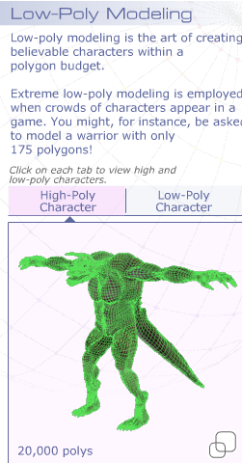
Welcome to GAD415 Low Polygon Modeling and Animation!
The performance of a game is essential to creating a satisfactory virtual play experience. Game performance is determined by the ability of the game engine to accomplish real-time rendering onscreen. This capability is limited by the polygon count of the scene, as well as the texture memory being used by image bitmaps for the materials. Low-poly modeling is critical for good game production because the performance of the game renderer will slow down with too many polys appearing in the scene at once. Each character and every object that appear in the view will add to the performance hit, so mesh economy is paramount.
Low Polygon Modeling and Animation is a course that lets you focus on effective modeling techniques to create videogame characters with the fewest polygons. You'll design and model a low-poly character from your own imagination. This modeling will be accomplished using a variety of 3D modeling techniques that let you explore the tools and controls for optimized and efficient character building. This course assumes you already know how to model using 3ds Max. It is an advanced course on modeling techniques.
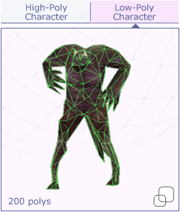
In this course, you'll learn:
- The reasons for low-poly modeling.
- Obstacles to low-poly modeling and how to overcome them.
- Methods to model characters efficiently.
- Methods to use to optimize existing character meshes.
- Using image maps as modeling references.
- Using opacity maps to replace geometry detail.
- Management techniques to organize your file assets.
During the six weeks of this class, you'll put into practice all of your modeling, texturing, rigging, animating, and rendering skills in 3ds Max. Your character will be limited to 1,000 polygons. You'll rig, skin, and animate the character that can perform an action in an environment. You'll learn to adjust the model's mesh structure to correct unwanted deformations. In this course, you'll also build a prop or weapon for your character and create a quick environment using opacity-mapped planes and objects. All of this effort will lead up to a final project, a finished looping movie of your animated character that you can use in your portfolio.
Let's take a look at what you'll cover in the coming weeks.

Learning Outcomes:
- Conceptualize 3D coordinate systems and construct 3D models.
- Employ preplanning comps and model layout sheets.
- Create low poly models using box modeling techniques.
- Create libraries of objects for props and character parts.

Week 1 begins with the review of the basic methods of 3D modeling and the application of these methods to create low-poly videogame characters. This week, the course covers the process of developing character designs using sketches and model sheets. You'll create reference bitmaps from scans (scanned images) of these sketches and position them in the viewports in preparation for modeling.
Week 2 covers the details of mesh modeling, using vertex, edge, and polygon techniques. Week Two will focus on modeling of the character's face and head, including eyes, nose, mouth, and any hair, hat, or helmet that is applicable to your design.
Week 3 covers spline modeling techniques, such as lathe modifier, lofting, and spline cage modeling. You'll learn to use the polygon counter. You'll also learn optimization techniques, such as Editable Poly Edge Removal, Optimize modifier, and MultiRes modifier. Week 3 focuses on modeling the character's torso, props, or weapons.
In Week 4, you'll learn to use materials and maps to replace and add detail to low-poly characters, props, and scene levels. In addition to texture, opacity, bump, and normal mapping, you'll focus on learning when to optimize the textures and the geometry. In Week 4, you'll model the environment for the character and use materials and mapping on the characters and level surroundings.
Week 5 provides information on managing assets and organizing files for the game project. In Week 5, you will rig, skin, and animate the character performing simple motion tests. You'll create rendered movies of your animations in Week 5.
In Week 6, you'll refine the animation created in Week 5. This week will be dedicated to polishing the animation and making any necessary corrections before rendering it again.

Final Project
The six weeks of this course build toward the single goal of creating an animation of a low-poly character that you have designed and modeled. That animation is the final project that each student will deliver in the last week of the course. To achieve this goal, each week, the work for the class will require you to deliver files that will build toward the final project. Let's review what you will need to do each week:
- In Week 1, you'll create the design for the character, using pencil and paper, and then scan those images in .BMP format to be used as reference images.
- In Week 2, you'll model the face and head of the character, as well as hair, hats, or helmets. You'll deliver a .MAX file for this aspect.
- In Week 3, you'll create the rest of the character's body, including arms, legs, hands, feet, boots, gloves, and so on. You'll also model any props or weapons associated with the character design. You'll deliver a .MAX file for this submission. The character should not have more than 1000 polygons.
- In Week 4, materials will be added to the characters, and the environment will be modeled or created out of image planes and opacity mapped objects. You'll deliver a .MAX file for this aspect. The bitmaps can be delivered in various formats, such as .TGA, .JPG, .PNG, or .BMP.
- In Week 5, characters will be rigged, skinned, animated, and rendered. You'll deliver a .MAX file of the character animation and a rendered .AVI or .MOV file.
- In Week 6, the animations will be improved, and a final rendered .AVI or Quicktime .MOV file will be produced as the completed Final Project submission.

3D Coordinate Systems—A Review
You've been studying 3D modeling and animation for some time now, so you should be quite familiar with the concepts of 3D Coordinate Systems. 3ds Max has some unique behaviors regarding 3D Coordinate Systems, particularly when doing 3D modeling. For this reason, we will review the concepts of 3D Coordinate Systems here, as there are important bits of information to know. If you don't understand how 3ds Max treats the use of 3D Coordinate Systems with transforms, you won't be able to model in 3ds Max very successfully.
The Cartesian coordinate system developed by Descartes is the standard used in modern mathematics today. It uses a tripod pointing in 3 directions and is labeled as X, Y, and Z axes as a means to define 3D space in a 2D display, such as a piece of paper or a computer monitor. It is a way of drawing 3D space on a flat surface.
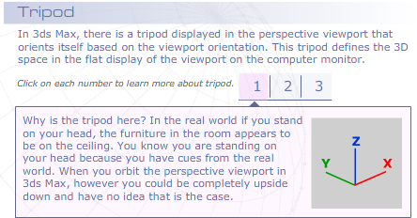
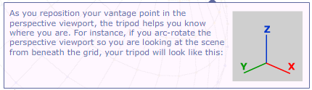
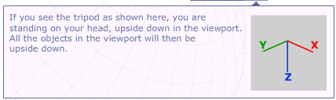
3ds Max uses the convention of labeling the Z-axis as the vertical axis, while other programs use the Y-axis as the vertical axis instead. This difference in axis labeling can become an issue if you import models from Maya or Lightwave. If you're importing models from these softwares, you may want to actually rotate the entire scene to reorient it, or live with the switch in the axes labels.
When moving, rotating, or scaling object or subobject selections, 3ds Max offers an additional coordinate system called Reference Coordinate Systems. This system is reflected in the axis labels found on the transform gizmo.

Move Transform Gizmo
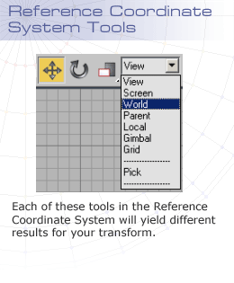
The syntax to choose your transform is on the main toolbar (Move, Rotate, or Scale); then in the Reference Coordinate System drop-down menu, you can choose from View, Screen, World, Parent, Local, Gimbal, or Grid. Each of these tools will yield different results for your transform. You can move your object in World space, Parent space, Local space, or even Screen space. The ability to change the space you want to move in is extremely useful, as it increases the options you have at any given moment. World space lets you move in a fixed XYZ orientation. View and Screen will take XYZ directions from the orientation of the viewport, so as you arc-rotate in the viewport, the direction shifts as well. Parent lets you work with hierarchical linkages, so you can move children in the parent-space orientation. You can also use the Pick command to select the coordinates system of another object in the scene and use that for your transform. This capability lets you rotate objects around other objects.
Axis Labels
Shifting Axis Labels
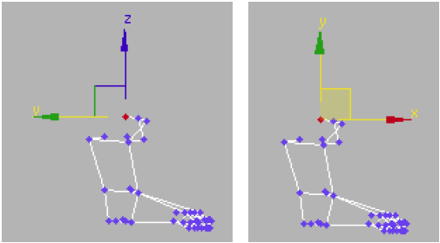
The geometry is in the left viewport. With World selected, Z is the vertical axis in the Left
Viewport, while with View selected; the Left Viewport has Y as the vertical axis instead of Z.

Moving the Vertices
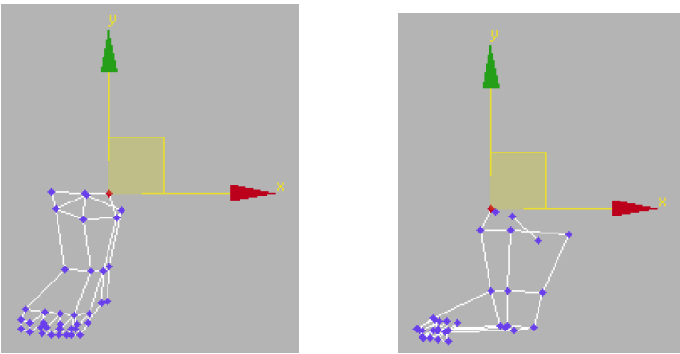
A good trick to try is to use the Screen Coordinate System while you’re modeling to move vertices
and edges. You can arc-rotate around your model in the Perspective viewport with Screen turned
on your gizmo and always stays parallel to the picture plane. This method is a handy way to work,
like a sculptor who keeps walking around a three-dimensional clay piece; you can orbit around
your work and move the vertices parallel to your own view. If you work from a particular viewpoint
for too long, you may not see accidents that have occurred, such as vertices that have moved
toward an unintended dimension.

Rotate your vantage point, move the vertices square to the view.

Scaling using Local Axes

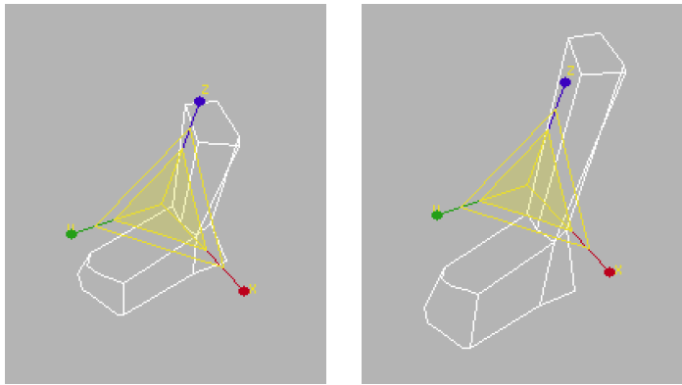
Use Local Axes to scale objects that have been rotated in the viewport. This will let you scale
geometry in the direction you want, when the coordinate system is not aligned to world XYZ.
When the boot has rotated away from the world XYZ space, if you scale using World reference
coordinate system, you will get skewing. By using Local Axes, you can scale the boot without a
problem.

Notice that 3ds Max uses View as the default reference coordinate type, which means that XYZ axes labels shift, based on the active viewport. If you change to World, you'll have a more standard behavior, where XYZ are always oriented, based on the World.
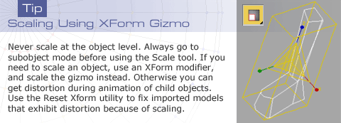

Character Sketches—Character Design Process
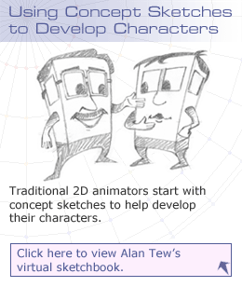
Although you have experienced the creation of characters in you previous classes, a quick overview of that process can help reinforce what you have learned and will ultimately provide you with a good solid start before you have to consider the restrictions and shortcuts necessary when limiting a character's polygons.
When you design a character, you pick up ideas from everywhere. It's a good idea to always carry a small sketchbook in your pocket. There are two main places where ideas can come from. First, they can come from your imagination. Try closing your eyes and imagining a character. What do you see with your eyes closed? Try to sketch that image. Or remember something you saw in a dream. Make a sketch of that. You can also just let the line that you draw provide the inspiration. All of these techniques hinge on using your imagination.
You may also find inspiration by observing the world around you. Observe animals or your fellow humans. What are the characteristics that catch your attention? Try to capture these characteristics in your drawings. By exaggerating these characteristics, you enter the road to character design. Exaggeration is one of the fundamental principles of animation. Both in your character design and your character's motions, exaggeration is what separates this art from simply copying nature.
Think about the character you want to design. You can write down characteristics that define the personality of the character, and then make the structure of that character reflect these characteristics to good effect. For example, perhaps you want to design a character that is pompous and full of himself. This character could have a huge head on a very small body. Or he could always have his nose up in the air, as if he is sniffing those around him, rather than actually seeing them. Watch the people around you, how they act, and their mannerisms. You can draw on these real observations for ideas.

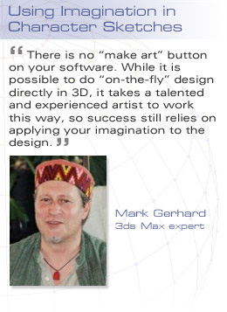
Use the process of drawing as a method of exploration. Don't try to draw perfect drawings; instead draw freely with abandon. It's important to draw quick sketches to flush out your ideas. You should try one and discard several ideas to arrive at the ones you like best. Imaginative designers are beset with ideas, but only some are good. Your job is to explore and uncover the ideas you like, the ones that best work for you.
It's also useful to emulate the masters. Look at the comics in your daily newspaper, and see how the master cartoonist uses the nature of the ink and brush to create effects. Where would Charlie Brown be without the circle, or the zigzag diagonal line? Look at the different characters and observe their proportions. What has been exaggerated and how does that exaggeration work to create a “readable” characteristic? Of course, you should study animated cartoons too. Go to the movies, and sketch during the film. Or use the freeze frame/pause capabilities on your home DVD or VCR to stop and copy characters you like.
Try to identify your favorite character, and then ask yourself why it is your favorite. When you know why you like a character, try creating other characters that use the same characteristics. Do you like the way the hair is spiky or the eyes are big in Anime characters? If so, try different ways to use these same kinds of exaggerations.
Finally, you'll have gathered good ideas that you want to realize. Take those ideas and let them expand into your full-blown character by drawing model sheets.

A Cautionary Note Here
Do not copy. If you design a character that looks just like a typical anime figure or hero that you like, it won't stand out from the rest of the crowd. What makes your character different from ones the public already knows? If the answer is nothing, don't waste your time.
You may be tempted to skip paper and pencil, thinking that drawing is unnecessary in the world of 3D modeling and design. Nothing could be further from the truth. Ask any artist who has used 3D software for a long time, and he or she will tell you how important it is that you learn to draw and then practice that art as often as you can.
While drawing your characters, try to establish the proportions of the character before laying in the detail. Too many novice designers start by drawing an eye and gradually move out from there. As in life drawing, character design should have the details added gradually. Start with a loose sketch and feel free to use your eraser if you're working in pencil. It's a mistake to painstakingly draw in details too soon, only to find that the proportions are not correct.
Another major mistake is not to consider the practical limits during character design. Do you have a polygon budget dictated by the game producer or game designer? Whatever you design you are going to have to model, so go easy on yourself. Perhaps a demon with 10 heads seems like a good idea at first, but it will be more difficult to achieve that demon in a low-poly model than a demon with just two heads. More heads equals more polys.

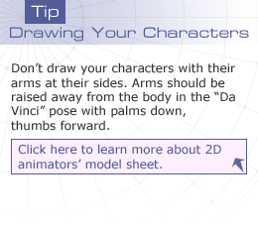
From Design to Model—Creating Model Sheets
The next step in creating a character is to create a kind of drawing called a model sheet. There are two kinds of model sheets commonly used in animation. In traditional 2D animation, a model sheet is used to create snapshots of the character in different characteristic poses, showing various facial expressions and performing various defining actions. These pages are loaded with drawings that show how the character looks, so that the in-betweeners can “stay on model.” The traditional practice of using a master animator to draw the key poses and then have the in-betweeners draw the breakdowns requires that the in-betweeners have reference material to use. If the drawings stray too far from the model sheet, the animation will not be convincing, and the characters will melt or morph and lose believability.
There are two different types of models sheets for different purposes: 2D model sheet as used for cartoon characters in traditional hand-drawn animation, and 3D model sheet as used for modeling game characters.
It isn't necessary in 3D animation to draw this type of model sheet, although it is a very good idea if you have a lot of facial expressions for morph targets. In 3D animation, the model sheet is used for a different purpose—to construct the model of the character, so it bears a strong likeness to the original design. In this sense, a model sheet is closer to an engineering drawing used by a contractor to build something, rather than serve as an artistic guide. You'll then use the model sheet as a reference bitmap that you'll place in the viewport during the modeling process.
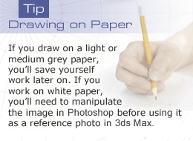
more about model sheets: http://www.animationbrain.com/2d-model-sheet.html
Usually a model sheet for 3D animation means using a number of side by side drawings of the character as seen from different angles. In the center of the page, draw the character as seen from the front. Then trace out horizontal lines from the top of the head and bottom of the chin. These represent one head's height. Now draw additional horizontal lines at two heads, three heads, and so forth down to the feet. Comic characters are usually 4–5 heads tall; heroic figures can be 7 or 8 heads tall.
Once you have your character drawn from the front, draw the side view. Use the horizontal lines as a guide to ensure that the drawing is proportionate. The drawing should look as though the character has turned to the side and the camera has not moved. The character is the same height from the side as it is from the front.
If the character has any pertinent detail that is required, draw a view from the back as well. You don't have to draw a top view; it's not very easy to be sure that the top view you draw is accurate.
Draw lightly with a hard pencil (HB) until you are happy with your design, then ink your drawing or darken the pencil lines with soft pencil (2B). Use artgum eraser to remove the pencil marks after the inking.

Maquettes—A Sculpture of Your Character
In the professional world of film and character design, sometimes a sculpture of the character is modeled using real-world materials. Often, a trained sculptor will be hired to create a plastic clay model to help in drawing the model sheet. You can create an armature by using welding wire or armature wire that is available at your local art store. Attach the armature to a piece of plywood or board and then build up your plastic clay figure on the armature. You can use sculpting tools to refine the surface. Once you have a plastic clay model, you can bake it to harden the sculpture. Then use the sculpture as a reference for your drawing of the model sheets. You can also bypass the model sheet by taking digital photos of the sculpture from the appropriate angles.
Click here to learn more about the maquettes of Batman, Superman, and other comic heroes.
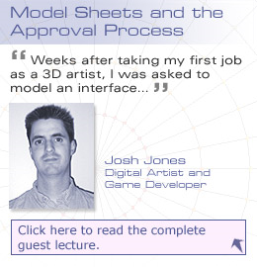
http://www.comicart.cc/maquette/

Model Sheets and the Approval Process
Guest Lecture: Josh Jones
Weeks after taking my first job as a 3D artist, I was asked to model an interface console for the science-fiction game 10th Planet. In my inexperience, I immediately jumped in to 3ds Max and began to model a robotic Heads-up Display (HUD) with a retro, post-modern feel. I spent at least one day working on this concept, only to be told by my supervisor that I was going in a direction he didn’t like at all. I could’ve saved many hours at the computer had I simply submitted my ideas on paper first.
Since then, I have always insisted on working from approved model sheets, even when art directors have not demanded it. The industry has many examples of games being shipped late or even being cancelled, as was the title 10th Planet, so avoiding inefficiencies should be the goal of every game developer.”
Josh Jones,
Digital Artist and Game Developer

Low-Poly Modeling Methods and Challenges
Low-poly modeling is a bit of a magic act. It requires that you maintain believability in your characters while working within your polygon budget. It means juggling the artistic realization of your character with the geometrical limitations the game engine sets.
The challenges in low-poly modeling are:
- The game producer or game designer dictates a polygon limit for your character. This limit is a fixed amount of triangular faces or polygon quads that you are supposed to use. Note that this is only a guideline, and that you may be able to use more polygons if you can convince the producer/designer that you need them. If they like your character, they may even give you a bonus amount of polygons to work with.
- The design of the character has to be convincing and believable to meet the approval criteria of the game producer or game designer. If your character is artistically not at par with the rest of the game design, your character will not be appreciated even if you are within polygon count.
- You have to satisfy the above two points, fixed poly budget and design, using the same character.
- Your character has to animate satisfactorily. You'll need extra polygons to account for specific animation. If your character has to smile, you'll need extra geometry at the corners of the mouth to accommodate this movement. If your character requires fingers that bend, this movement will necessitate extra segments in the hands.
The methods for low-polygon modeling can be accomplished in one of two ways:
- Model your character without regard to polygon count, then optimize it to fit your polygon budget.

- Model your character with an eye to polygon budget, adjusting your model as you go to match your character's design without exceeding your limit. It's generally easier to model in this fashion rather than using the first alternative.
The real trick is that if you are handed a design to model, the designer may not have designed something that can be modeled within the assigned polygon count. In that case, you'll need to lobby for either a change in the character design or an increase in polygon budget.
The most common mistake in design/animation/modeling comes from lack of communication. If you are not the character designer, you must communicate up front if you feel it will be difficult to model the character within the given polygon limits. If the game producer or the designer has his heart set on a giant squid character with 24 tentacles and dreadlocks, you'll need to convince them you'll either need more than 400 polygons or they'll need to give up the dreadlocks. Whoever suggested the dreadlocks didn't stop to think what it costs in terms of geometry and whether or not you can afford it.
It can be fun to pull off creating a complex model within a certain number of polygons. There are decisions to be made in terms of where you can cut back and where you can't. You need to work closely with your team members to manage the expectations of a game producer or designer to succeed. No one likes nasty surprises, especially when it's too late to incorporate changes. If you face problems, ask for help early on, or at least alert the designer as to the dilemma you face. Don't forget that the model is only one part of the battle. Once the model is complete, you have to animate the model, and that animation may require more geometry to avoid character deformation.
No Such Thing as a “Fixed” Budget
In my experience, the polygon budget can be negotiable, as art directors and producers
sometimes will say “up the polys” often with good cause, but not always. Programmers and
anyone else responsible for making the game run at optimal speed and fit on a disk probably
cringe at this polygon budget, but the truth is that often games experience “polygon-creep,” a
similar concept to feature-creep.
However, if an artist is skilled enough to make a model look good with minimal polys the first time
around, then he can help avoid the headaches of having to later optimize a model that was not
made to spec.

Josh Jones,
Digital Artist and Game Developer

Modeling with Reference Photos
Once you've created a model sheet, you can create reference bitmaps to use in the modeling process. There are a number of aspects to consider when creating these bitmap scans. First, you want to make sure that the scans will be visible, so the line work of the drawings must be crisp and clean. Using black ink or soft dark pencil is advised.
Scan in the front view from the model sheet; then in Photoshop, paint and crop the image as needed, so only the front view is visible in the scan. Repeat the process for the side view (either left or right). Make sure that the bitmaps you save are the same height and width and that the character stays in the same place in the image. If the front view has 3 pixels of background under the feet, the left view should also have 3 pixels of background image under the feet.
You'll use these scans as references for your modeling. As 3ds Max uses white as the default color for drawing splines, it's a good idea to tone down the background in the scan. You can do so by adjusting the contrast and brightness of the scan in Photoshop to remove the white of the paper. Of course, it's easier if you draw your model sheet on light grey paper; then your scan won't have a white background, and you can avert the problem and the correction.
When you have the scans ready, you have two options in 3ds Max. You can use these as Viewport Backgrounds, or you can map them as texture maps to planes in the viewport. Most modelers find that using Viewport Backgrounds appears convenient at first, but requires some extra work and manipulation to succeed in the end. Also Viewport backgrounds have some bugs that may drive you crazy. They tend to jump around unexpectedly, causing you to reregister your models against them. Mapped planes are simpler to set up and are usually preferred by professionals. If you use mapped planes, you may have trouble drawing splines that appear behind the mapped planes, however. If you do a lot of spline modeling, you may want to stick with Viewport backgrounds.
In either case, care must be taken that the reference photos are not distorted. Here's a quick method to ensure this aspect by using Viewport Backgrounds:

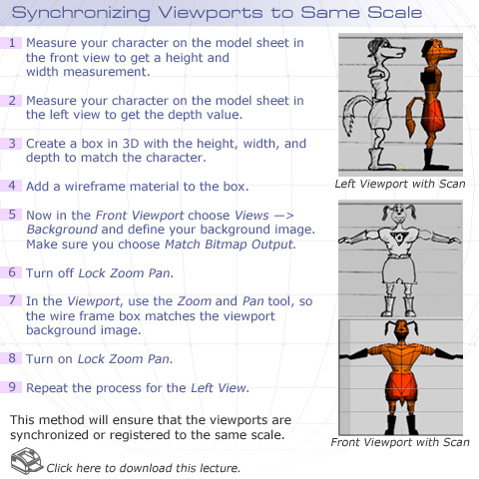
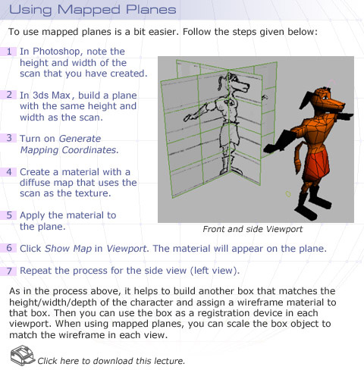

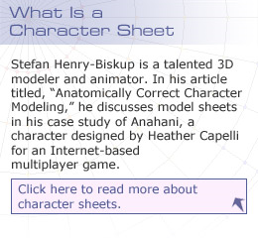
Limitations of the Viewport Background
First, the Viewport background can get out of register with the geometry if you turn off Lock Zoom Pan. If this does happen, you can use the wireframe to reregister the geometry with the background. Second, if you try to zoom into the background, you may get a warning message, saying that 3ds Max will need to use some gigantic amount of memory in order for you to zoom in. If your detail is such that you want to use this type of zoom, you should use the mapped plane method instead. You can use higher resolution scans for your textures than you can for your backgrounds. However, in low-poly character modeling, it is unlikely you will require this kind of detail in geometry. Chances are that if you do, however, you'll run into polygon count issues from modeling with greater detail than you can afford.
Once the mapping planes are in place, you do not want to inadvertently move them. To prevent this problem, select all of your planes, and in their Display Properties turn off Show Frozen in Gray then click OK. Then right-click and Freeze the planes. Now they are frozen and unselectable, yet still visible in the viewport.
Anatomically correct characters link: http://www.gamasutra.com/view/feature/3295/anatomically_correct_character_.php

Summary

Congratulations! You've finished reading the lectures for Week 1!
You've examined 3D coordinate systems in 3ds Max and how the different transforms can use a variety of selectable reference coordinate systems. You've also re-explored the process of character design and experienced creating model sheets. You've been exposed to the two methods (Viewport Background or Mapped Planes) you can use to take those model sheets and turn them into reference bitmaps to use in modeling. Then you've learned about the challenges and obstacles that low-poly modelers face when starting a character modeling project.
Next week, you'll design a character, sketch its model sheets, and scan them into bitmaps. Using these sheets as reference photos you will model your character over the next several weeks. When you model your character, you'll have to balance the need for detail vs. polygon economy.
Next week's lectures will focus on the modeling tools that 3ds Max provides for box modeling techniques. Basic vertex manipulation and polygon extrusion tools will be covered, giving you the fundamental techniques you will use to build low-poly characters.

Assignment 1: Autobiography
By Monday, April 5, 2010, submit your autobiography to the appropriate Discussion Area. The autobiography should include the following details:
- Name
- Work experience
- Your expectations for the course and your career in games.
- A quick pencil self-portrait sketch scanned into the computer and included
- as a .JPG file.
- A character autobiography that you will create in this course's Final Project.
Review and comment on the autobiographies of other students by the end of the week.
Grading Criteria | Maximum Points
Posted autobiographical information. | 1
Stated expectations for the course. | 1
Stated the career path you envision for yourself. | 1
Submitted a scanned image of self-portrait sketch in .JPG format. | 1
Submitted a charcter biography for the course' Final Project with a detailed explanation. | 2
Critiques of classmates' character biographies | 4
Total: | 10
For assistance with any problems you may have when completing this assignment—OR—to offer your assistance to classmates, please use the Problems and Solutions Discussion area located through the left side navigation link.
Note:
Critique the character autobiographies of at least 2 classmates.
I have outlined requirements for critiques in the Welcome Announcement; I’ll review them briefly here:
Each critique must include commentary on 2 things that are working, with reasons why, and two things that are not working, with reasons why – and how they might be improved.
Assignment 2: Discussion Questions
By Wednesday, April 7, 2010, respond to the discussion questions assigned to you by your facilitator. Submit your responses to the appropriate Discussion Area. Start reviewing and responding to your classmates' discussions as early in the week as possible.
Grading Criteria | Maximum Points
Response Criteria
Met the criteria for the correct responses to the questions assigned. | 6
Used vocabulary relevant to the current week's topics—at least five terms. | 6
Participation Criteria
Used vocabulary relevant to the current week's topics—at least five terms. | 6
Participated in the discussion by asking a question, providing a statement of clarification, providing a point of view with a rationale, challenging a point of discussion, or drawing a relationship between one or more points of the discussion. | 6
Justified ideas and responses by using appropriate examples and references from texts, Web sites, other references, or personal experience. | 6
Total: | 30
For assistance with any problems you may have when completing this assignment—OR—to offer your assistance to classmates, please use the Problems and Solutions Discussion area located through the left side navigation link.
Answer any 2 discussion questions. I look forward to an interesting discussion!
- Todd
DQ 1 - Research the different techniques sculptors use to create sculptures. How do these traditional techniques correspond to virtual methodologies within 3ds Max? Compare and contrast the traditional techniques with the virtual methodologies in 3ds Max. Which techniques lend themselves best to low-poly modeling?
DQ 2 - While creating a 3D model, where do you need more polygons and where can you get away with fewer polygons? Do you agree with your peers' responses? Give reasons.
DQ 3 - Locate and download at least two sample model sheets for your favorite cartoon characters from the Internet. Identify the best model sheet out of those two, and state why you think it is the best.
Discuss what problems model sheets help overcome for 2D animators and 3D modelers.
Note: In case you're unable to locate the model sheets on the Internet, use the model sheets that you created in some of your previous courses.
DQ 4 - What are the specifications for creating a good model sheet? Prepare a comprehensive checklist to validate your points.
What are the techniques you can use to make sure your model sheets scanned into the viewports are proportionate and of the same scale? Do you agree with your peers' responses? Give reasons.
Assignment 3: Final Project—Designing your Game Character
Create concept sketches for a game character with a prop. Draw sketches on paper, and then scan the sketches into the computer to save as .BMP format. Your character's props could be a weapon like a sword, club or gun, or something entirely different and original. Using pencil and paper, draw a model sheet for your character. Be sure to draw a front view and left view. By Friday, April 9, 2010, scan these views into multiple .BMP files, and post the files on the appropriate Discussion Area. Review the proposed timeline that contains a list of tasks to get an idea of what will be expected through the course. Review and comment on at least two students' game characters by the end of the week.
Grading Criteria | Maximum Points
Created concept sketches with a prop. | 8
Drew sketches on paper, scanned and saved them as .BMP format. | 5
Drew model sheets using pencil and paper for front and side views of their character. | 8
Scanned the front and side views as separate .BMP files proportionate and in the same scale as each other. | 4
Total: | 25
For assistance with any problems you may have when completing this assignment—OR—to offer your assistance to classmates, please use the Problems and Solutions Discussion area located through the left side navigation link.
NOTE:
Your game character will need to be 1000 polygons or less, so plan accordingly! Also note that this is 1000 triangles, so be sure that you are checking the right stats in Max!
I look forward to reviewing your concept sketches!
- Todd

Assignment 4: Exploring 3ds Max
Explore the 3ds Max toolset on your own. Explore the various features, actions, menus, and options of the software on your own.
By Friday, April 9, 2010, post your findings and discoveries to the 3ds Max Problems and Solutions Discussion Area. Also, post the challenges you faced in the entire process and how you tackled those. In addition, also share some tips and best practices with your peers and suggest solutions to the challenges faced by them.
Grading Criteria | Maximum Points
Posted findings and discoveries gained while exploring the 3ds Max toolset. | 4
Actively participated in the 3ds Max Problems and Solutions Discussion Area. | 4
Total: | 8
For assistance with any problems you may have when completing this assignment—OR—to offer your assistance to classmates, please use the Problems and Solutions Discussion area located through the left side navigation link.
NOTE:
This assignment asks you to explore 3D Studio Max beyond the requirements of your other assignments, and independent of those assignments. Learn something new about the software that will be useful to you, and share it with your classmates.
It also asks you to interact with your classmates, and offer tips and advice. You can ask for input from your classmates, but be sure that you do what is asked in the paragraph above.
- Todd

